Configuration Tomcat Sous Eclipse pour Naca, sur un PC de développement, ave cplugin sysdeo.

- Un tomcat 5.5 est installé en C:\Program Files\Apache Software Foundation\Tomcat
- Installer le plugin sysdeo dans eclispe
- Configurer Tomcat dans les préférences d'Eclipse:
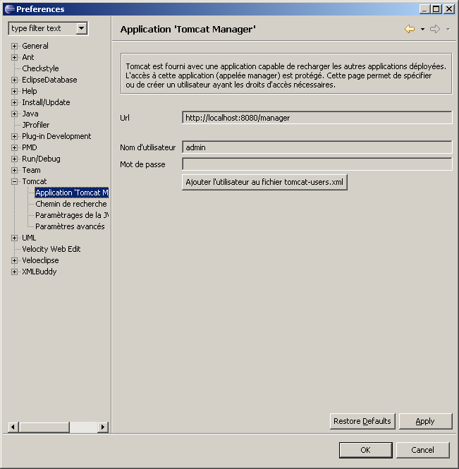

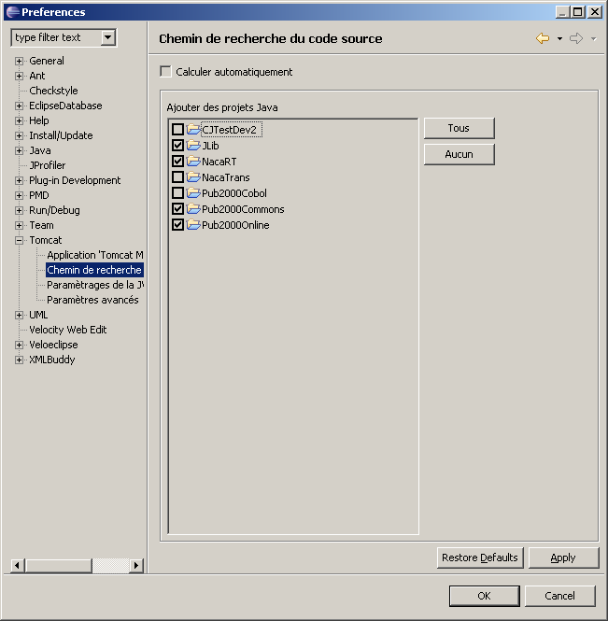
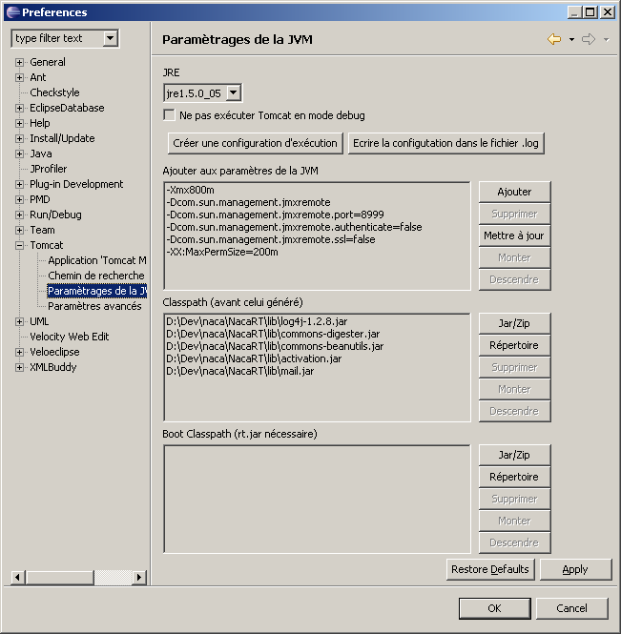

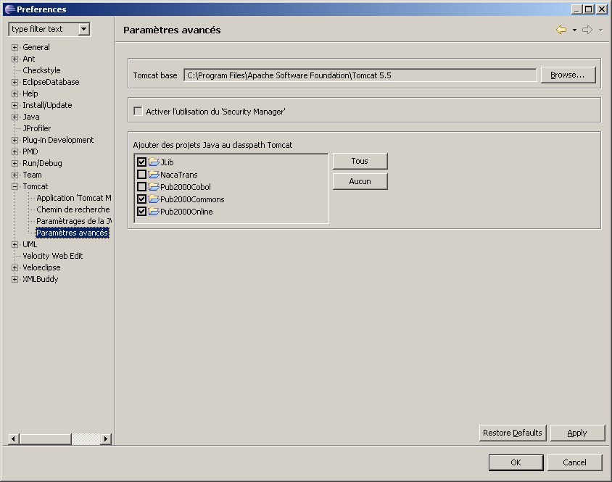

- Déclarer le projet Naca en tant que projet Tomcat, en mettant à jour le context:
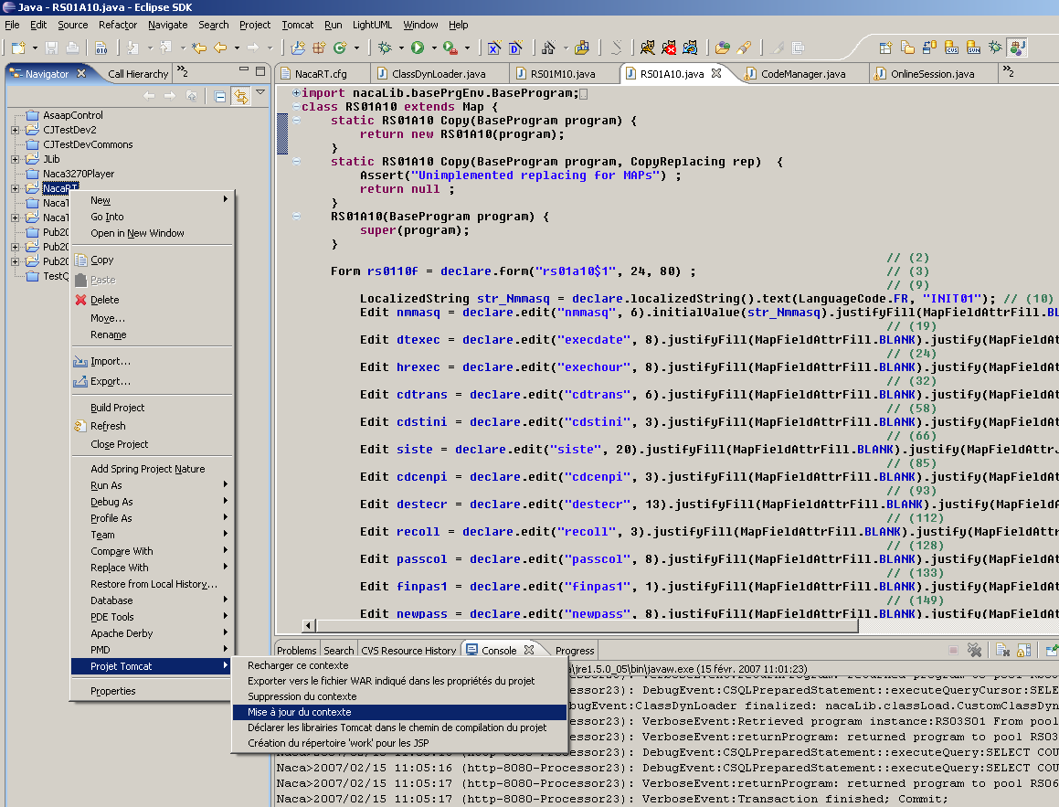

Le fichier C:\Program Files\Apache Software Foundation\Tomcat 5.5\conf\web.xml doit contenir:

<?xml version="1.0" encoding="ISO-8859-1"?>
<web-app xmlns="http://java.sun.com/xml/ns/j2ee"
xmlns:xsi="http://www.w3.org/2001/XMLSchema-instance"
xsi:schemaLocation="http://java.sun.com/xml/ns/j2ee http://java.sun.com/xml/ns/j2ee/web-app_2_4.xsd"
version="2.4">

<!-- ======================== Introduction ============================== -->
<!-- This document defines default values for *all* web applications -->
<!-- loaded into this instance of Tomcat. As each application is -->
<!-- deployed, this file is processed, followed by the -->
<!-- "/WEB-INF/web.xml" deployment descriptor from your own -->
<!-- applications. -->
<!-- -->
<!-- WARNING: Do not configure application-specific resources here! -->
<!-- They should go in the "/WEB-INF/web.xml" file in your application. -->

<!-- ================== Built In Servlet Definitions ==================== -->

<!-- The default servlet for all web applications, that serves static -->
<!-- resources. It processes all requests that are not mapped to other -->
<!-- servlets with servlet mappings (defined either here or in your own -->
<!-- web.xml file. This servlet supports the following initialization -->
<!-- parameters (default values are in square brackets): -->
<!-- -->
<!-- debug Debugging detail level for messages logged -->
<!-- by this servlet. [0] -->
<!-- -->
<!-- fileEncoding Encoding to be used to read static resources -->
<!-- [platform default] -->
<!-- -->
<!-- input Input buffer size (in bytes) when reading -->
<!-- resources to be served. [2048] -->
<!-- -->
<!-- listings Should directory listings be produced if there -->
<!-- is no welcome file in this directory? [false] -->
<!-- WARNING: Listings for directories with many -->
<!-- entries can be slow and may consume -->
<!-- significant proportions of server resources. -->
<!-- -->
<!-- output Output buffer size (in bytes) when writing -->
<!-- resources to be served. [2048] -->
<!-- -->
<!-- readonly Is this context "read only", so HTTP -->
<!-- commands like PUT and DELETE are -->
<!-- rejected? [true] -->
<!-- -->
<!-- readmeFile File name to display with the directory -->
<!-- contents. [null] -->
<!-- -->
<!-- sendfileSize If the connector used supports sendfile, this -->
<!-- represents the minimal file size in KB for -->
<!-- which sendfile will be used. Use a negative -->
<!-- value to always disable sendfile. [48] -->
<!-- -->
<!-- For directory listing customization. Checks localXsltFile, then -->
<!-- globalXsltFile, then defaults to original behavior. -->
<!-- -->
<!-- localXsltFile Make directory listings an XML doc and -->
<!-- pass the result to this style sheet residing -->
<!-- in that directory. This overrides -->
<!-- globalXsltFile[null] -->
<!-- -->
<!-- globalXsltFile Site wide configuration version of -->
<!-- localXsltFile This argument is expected -->
<!-- to be a physical file. [null] -->
<!-- -->
<!-- -->

<servlet>
<servlet-name>default</servlet-name>
<servlet-class>org.apache.catalina.servlets.DefaultServlet</servlet-class>
<init-param>
<param-name>debug</param-name>
<param-value>0</param-value>
</init-param>
<init-param>
<param-name>listings</param-name>
<param-value>false</param-value>
</init-param>
<load-on-startup>1</load-on-startup>
</servlet>

<!-- The "invoker" servlet, which executes anonymous servlet classes -->
<!-- that have not been defined in a web.xml file. Traditionally, this -->
<!-- servlet is mapped to the URL pattern "/servlet/*", but you can map -->
<!-- it to other patterns as well. The extra path info portion of such a -->
<!-- request must be the fully qualified class name of a Java class that -->
<!-- implements Servlet (or extends HttpServlet), or the servlet name -->
<!-- of an existing servlet definition. This servlet supports the -->
<!-- following initialization parameters (default values are in square -->
<!-- brackets): -->
<!-- -->
<!-- debug Debugging detail level for messages logged -->
<!-- by this servlet. [0] -->

<!--
<servlet>
<servlet-name>invoker</servlet-name>
<servlet-class>
org.apache.catalina.servlets.InvokerServlet
</servlet-class>
<init-param>
<param-name>debug</param-name>
<param-value>0</param-value>
</init-param>
<load-on-startup>2</load-on-startup>
</servlet>
-->

<!-- The JSP page compiler and execution servlet, which is the mechanism -->
<!-- used by Tomcat to support JSP pages. Traditionally, this servlet -->
<!-- is mapped to the URL pattern "*.jsp". This servlet supports the -->
<!-- following initialization parameters (default values are in square -->
<!-- brackets): -->
<!-- -->
<!-- checkInterval If development is false and checkInterval is -->
<!-- greater than zero, background compilations are -->
<!-- enabled. checkInterval is the time in seconds -->
<!-- between checks to see if a JSP page needs to -->
<!-- be recompiled. [0] -->
<!-- -->
<!-- modificationTestInterval -->
<!-- Causes a JSP (and its dependent files) to not -->
<!-- be checked for modification during the -->
<!-- specified time interval (in seconds) from the -->
<!-- last time the JSP was checked for -->
<!-- modification. A value of 0 will cause the JSP -->
<!-- to be checked on every access. -->
<!-- Used in development mode only. [4] -->
<!-- -->
<!-- compiler Which compiler Ant should use to compile JSP -->
<!-- pages. See the Ant documentation for more -->
<!-- information. [javac] -->
<!-- -->
<!-- classdebuginfo Should the class file be compiled with -->
<!-- debugging information? [true] -->
<!-- -->
<!-- classpath What class path should I use while compiling -->
<!-- generated servlets? [Created dynamically -->
<!-- based on the current web application] -->
<!-- -->
<!-- development Is Jasper used in development mode? If true, -->
<!-- the frequency at which JSPs are checked for -->
<!-- modification may be specified via the -->
<!-- modificationTestInterval parameter. [true] -->
<!-- -->
<!-- enablePooling Determines whether tag handler pooling is -->
<!-- enabled [true] -->
<!-- -->
<!-- fork Tell Ant to fork compiles of JSP pages so that -->
<!-- a separate JVM is used for JSP page compiles -->
<!-- from the one Tomcat is running in. [true] -->
<!-- -->
<!-- ieClassId The class-id value to be sent to Internet -->
<!-- Explorer when using <jsp:plugin> tags. -->
<!-- [clsid:8AD9C840-044E-11D1-B3E9-00805F499D93] -->
<!-- -->
<!-- javaEncoding Java file encoding to use for generating java -->
<!-- source files. [UTF8] -->
<!-- -->
<!-- keepgenerated Should we keep the generated Java source code -->
<!-- for each page instead of deleting it? [true] -->
<!-- -->
<!-- mappedfile Should we generate static content with one -->
<!-- print statement per input line, to ease -->
<!-- debugging? [true] -->
<!-- -->
<!-- trimSpaces Should white spaces in template text between -->
<!-- actions or directives be trimmed? [false] -->
<!-- -->
<!-- suppressSmap Should the generation of SMAP info for JSR45 -->
<!-- debugging be suppressed? [false] -->
<!-- -->
<!-- dumpSmap Should the SMAP info for JSR45 debugging be -->
<!-- dumped to a file? [false] -->
<!-- False if suppressSmap is true -->
<!-- -->
<!-- genStrAsCharArray Should text strings be generated as char -->
<!-- arrays, to improve performance in some cases? -->
<!-- [false] -->
<!-- -->
<!-- errorOnUseBeanInvalidClassAttribute -->
<!-- Should Jasper issue an error when the value of -->
<!-- the class attribute in an useBean action is -->
<!-- not a valid bean class? [true] -->
<!-- -->
<!-- scratchdir What scratch directory should we use when -->
<!-- compiling JSP pages? [default work directory -->
<!-- for the current web application] -->
<!-- -->
<!-- xpoweredBy Determines whether X-Powered-By response -->
<!-- header is added by generated servlet [false] -->
<!-- -->
<!-- compilerTargetVM Compiler target VM -->
<!-- default is System.properties -->
<!-- java.specification.version > 1.4 -->
<!-- [1.5] else [1.4] -->
<!-- -->
<!-- compilerSourceVM Compiler source VM -->
<!-- default is System.properties -->
<!-- java.specification.version > 1.4 -->
<!-- [1.5] else [1.4] -->
<!-- -->
<!-- If you wish to use Jikes to compile JSP pages: -->
<!-- Please see the "Using Jikes" section of the Jasper-HowTo -->
<!-- page in the Tomcat documentation. -->

<servlet>
<servlet-name>jsp</servlet-name>
<servlet-class>org.apache.jasper.servlet.JspServlet</servlet-class>
<init-param>
<param-name>fork</param-name>
<param-value>false</param-value>
</init-param>
<init-param>
<param-name>xpoweredBy</param-name>
<param-value>false</param-value>
</init-param>
<load-on-startup>3</load-on-startup>
</servlet>

<!-- NOTE: An SSI Filter is also available as an alternative SSI -->
<!-- implementation. Use either the Servlet or the Filter but NOT both. -->
<!-- -->
<!-- Server Side Includes processing servlet, which processes SSI -->
<!-- directives in HTML pages consistent with similar support in web -->
<!-- servers like Apache. Traditionally, this servlet is mapped to the -->
<!-- URL pattern "*.shtml". This servlet supports the following -->
<!-- initialization parameters (default values are in square brackets): -->
<!-- -->
<!-- buffered Should output from this servlet be buffered? -->
<!-- (0=false, 1=true) [0] -->
<!-- -->
<!-- debug Debugging detail level for messages logged -->
<!-- by this servlet. [0] -->
<!-- -->
<!-- expires The number of seconds before a page with SSI -->
<!-- directives will expire. [No default] -->
<!-- -->
<!-- isVirtualWebappRelative -->
<!-- Should "virtual" paths be interpreted as -->
<!-- relative to the context root, instead of -->
<!-- the server root? (0=false, 1=true) [0] -->
<!-- -->
<!-- inputEncoding The encoding to assume for SSI resources if -->
<!-- one is not available from the resource. -->
<!-- [Platform default] -->
<!-- -->
<!-- outputEncoding The encoding to use for the page that results -->
<!-- from the SSI processing. [UTF-8] -->
<!-- -->
<!-- -->
<!-- IMPORTANT: To use the SSI servlet, you also need to rename the -->
<!-- $CATALINA_HOME/server/lib/servlets-ssi.renametojar file -->
<!-- to $CATALINA_HOME/server/lib/servlets-ssi.jar -->

<!--
<servlet>
<servlet-name>ssi</servlet-name>
<servlet-class>
org.apache.catalina.ssi.SSIServlet
</servlet-class>
<init-param>
<param-name>buffered</param-name>
<param-value>1</param-value>
</init-param>
<init-param>
<param-name>debug</param-name>
<param-value>0</param-value>
</init-param>
<init-param>
<param-name>expires</param-name>
<param-value>666</param-value>
</init-param>
<init-param>
<param-name>isVirtualWebappRelative</param-name>
<param-value>0</param-value>
</init-param>
<load-on-startup>4</load-on-startup>
</servlet>
-->

<!-- Common Gateway Includes (CGI) processing servlet, which supports -->
<!-- execution of external applications that conform to the CGI spec -->
<!-- requirements. Typically, this servlet is mapped to the URL pattern -->
<!-- "/cgi-bin/*", which means that any CGI applications that are -->
<!-- executed must be present within the web application. This servlet -->
<!-- supports the following initialization parameters (default values -->
<!-- are in square brackets): -->
<!-- -->
<!-- cgiPathPrefix The CGI search path will start at -->
<!-- webAppRootDir + File.separator + this prefix. -->
<!-- [WEB-INF/cgi] -->
<!-- -->
<!-- debug Debugging detail level for messages logged -->
<!-- by this servlet. [0] -->
<!-- -->
<!-- executable Name of the exectuable used to run the -->
<!-- script. [perl] -->
<!-- -->
<!-- parameterEncoding Name of parameter encoding to be used with -->
<!-- CGI servlet. -->
<!-- [System.getProperty("file.encoding","UTF-8")] -->
<!-- -->
<!-- passShellEnvironment Should the shell environment variables (if -->
<!-- any) be passed to the CGI script? [false] -->
<!-- -->
<!-- IMPORTANT: To use the CGI servlet, you also need to rename the -->
<!-- $CATALINA_HOME/server/lib/servlets-cgi.renametojar file -->
<!-- to $CATALINA_HOME/server/lib/servlets-cgi.jar -->

<!--
<servlet>
<servlet-name>cgi</servlet-name>
<servlet-class>org.apache.catalina.servlets.CGIServlet</servlet-class>
<init-param>
<param-name>debug</param-name>
<param-value>0</param-value>
</init-param>
<init-param>
<param-name>cgiPathPrefix</param-name>
<param-value>WEB-INF/cgi</param-value>
</init-param>
<load-on-startup>5</load-on-startup>
</servlet>
-->

<!-- ================ Built In Servlet Mappings ========================= -->

<!-- The servlet mappings for the built in servlets defined above. Note -->
<!-- that, by default, the CGI and SSI servlets are *not* mapped. You -->
<!-- must uncomment these mappings (or add them to your application's own -->
<!-- web.xml deployment descriptor) to enable these services -->

<!-- The mapping for the default servlet -->
<servlet-mapping>
<servlet-name>default</servlet-name>
<url-pattern>/</url-pattern>
</servlet-mapping>

<!-- The mapping for the invoker servlet -->
<!--
<servlet-mapping>
<servlet-name>invoker</servlet-name>
<url-pattern>/servlet/*</url-pattern>
</servlet-mapping>
-->

<!-- The mapping for the JSP servlet -->
<servlet-mapping>
<servlet-name>jsp</servlet-name>
<url-pattern>*.jsp</url-pattern>
</servlet-mapping>

<servlet-mapping>
<servlet-name>jsp</servlet-name>
<url-pattern>*.jspx</url-pattern>
</servlet-mapping>

<!-- The mapping for the SSI servlet -->
<!--
<servlet-mapping>
<servlet-name>ssi</servlet-name>
<url-pattern>*.shtml</url-pattern>
</servlet-mapping>
-->

<!-- The mapping for the CGI Gateway servlet -->

<!--
<servlet-mapping>
<servlet-name>cgi</servlet-name>
<url-pattern>/cgi-bin/*</url-pattern>
</servlet-mapping>
-->

<!-- ================== Built In Filter Definitions ===================== -->

<!-- NOTE: An SSI Servlet is also available as an alternative SSI -->
<!-- implementation. Use either the Servlet or the Filter but NOT both. -->
<!-- -->
<!-- Server Side Includes processing filter, which processes SSI -->
<!-- directives in HTML pages consistent with similar support in web -->
<!-- servers like Apache. Traditionally, this filter is mapped to the -->
<!-- URL pattern "*.shtml", though it can be mapped to "*" as it will -->
<!-- selectively enable/disable SSI processing based on mime types. For -->
<!-- this to work you will need to uncomment the .shtml mime type -->
<!-- definition towards the bottom of this file. -->
<!-- The contentType init param allows you to apply SSI processing to JSP -->
<!-- pages, javascript, or any other content you wish. This filter -->
<!-- supports the following initialization parameters (default values are -->
<!-- in square brackets): -->
<!-- -->
<!-- contentType A regex pattern that must be matched before -->
<!-- SSI processing is applied. -->
<!-- [text/x-server-parsed-html(;.*)?] -->
<!-- -->
<!-- debug Debugging detail level for messages logged -->
<!-- by this servlet. [0] -->
<!-- -->
<!-- expires The number of seconds before a page with SSI -->
<!-- directives will expire. [No default] -->
<!-- -->
<!-- isVirtualWebappRelative -->
<!-- Should "virtual" paths be interpreted as -->
<!-- relative to the context root, instead of -->
<!-- the server root? (0=false, 1=true) [0] -->
<!-- -->
<!-- -->
<!-- IMPORTANT: To use the SSI filter, you also need to rename the -->
<!-- $CATALINA_HOME/server/lib/servlets-ssi.renametojar file -->
<!-- to $CATALINA_HOME/server/lib/servlets-ssi.jar -->

<!--
<filter>
<filter-name>ssi</filter-name>
<filter-class>
org.apache.catalina.ssi.SSIFilter
</filter-class>
<init-param>
<param-name>contentType</param-name>
<param-value>text/x-server-parsed-html(;.*)?</param-value>
</init-param>
<init-param>
<param-name>debug</param-name>
<param-value>0</param-value>
</init-param>
<init-param>
<param-name>expires</param-name>
<param-value>666</param-value>
</init-param>
<init-param>
<param-name>isVirtualWebappRelative</param-name>
<param-value>0</param-value>
</init-param>
</filter>
-->

<!-- ==================== Built In Filter Mappings ====================== -->

<!-- The mapping for the SSI Filter -->
<!--
<filter-mapping>
<filter-name>ssi</filter-name>
<url-pattern>*.shtml</url-pattern>
</filter-mapping>
-->

<!-- ==================== Default Session Configuration ================= -->
<!-- You can set the default session timeout (in minutes) for all newly -->
<!-- created sessions by modifying the value below. -->

<session-config>
<session-timeout>30</session-timeout>
</session-config>

<!-- ===================== Default MIME Type Mappings =================== -->
<!-- When serving static resources, Tomcat will automatically generate -->
<!-- a "Content-Type" header based on the resource's filename extension, -->
<!-- based on these mappings. Additional mappings can be added here (to -->
<!-- apply to all web applications), or in your own application's web.xml -->
<!-- deployment descriptor. -->

<mime-mapping>
<extension>abs</extension>
<mime-type>audio/x-mpeg</mime-type>
</mime-mapping>
<mime-mapping>
<extension>ai</extension>
<mime-type>application/postscript</mime-type>
</mime-mapping>
<mime-mapping>
<extension>aif</extension>
<mime-type>audio/x-aiff</mime-type>
</mime-mapping>
<mime-mapping>
<extension>aifc</extension>
<mime-type>audio/x-aiff</mime-type>
</mime-mapping>
<mime-mapping>
<extension>aiff</extension>
<mime-type>audio/x-aiff</mime-type>
</mime-mapping>
<mime-mapping>
<extension>aim</extension>
<mime-type>application/x-aim</mime-type>
</mime-mapping>
<mime-mapping>
<extension>art</extension>
<mime-type>image/x-jg</mime-type>
</mime-mapping>
<mime-mapping>
<extension>asf</extension>
<mime-type>video/x-ms-asf</mime-type>
</mime-mapping>
<mime-mapping>
<extension>asx</extension>
<mime-type>video/x-ms-asf</mime-type>
</mime-mapping>
<mime-mapping>
<extension>au</extension>
<mime-type>audio/basic</mime-type>
</mime-mapping>
<mime-mapping>
<extension>avi</extension>
<mime-type>video/x-msvideo</mime-type>
</mime-mapping>
<mime-mapping>
<extension>avx</extension>
<mime-type>video/x-rad-screenplay</mime-type>
</mime-mapping>
<mime-mapping>
<extension>bcpio</extension>
<mime-type>application/x-bcpio</mime-type>
</mime-mapping>
<mime-mapping>
<extension>bin</extension>
<mime-type>application/octet-stream</mime-type>
</mime-mapping>
<mime-mapping>
<extension>bmp</extension>
<mime-type>image/bmp</mime-type>
</mime-mapping>
<mime-mapping>
<extension>body</extension>
<mime-type>text/html</mime-type>
</mime-mapping>
<mime-mapping>
<extension>cdf</extension>
<mime-type>application/x-netcdf</mime-type>
</mime-mapping>
<mime-mapping>
<extension>cer</extension>
<mime-type>application/x-x509-ca-cert</mime-type>
</mime-mapping>
<mime-mapping>
<extension>class</extension>
<mime-type>application/java</mime-type>
</mime-mapping>
<mime-mapping>
<extension>cpio</extension>
<mime-type>application/x-cpio</mime-type>
</mime-mapping>
<mime-mapping>
<extension>csh</extension>
<mime-type>application/x-csh</mime-type>
</mime-mapping>
<mime-mapping>
<extension>css</extension>
<mime-type>text/css</mime-type>
</mime-mapping>
<mime-mapping>
<extension>dib</extension>
<mime-type>image/bmp</mime-type>
</mime-mapping>
<mime-mapping>
<extension>doc</extension>
<mime-type>application/msword</mime-type>
</mime-mapping>
<mime-mapping>
<extension>dtd</extension>
<mime-type>application/xml-dtd</mime-type>
</mime-mapping>
<mime-mapping>
<extension>dv</extension>
<mime-type>video/x-dv</mime-type>
</mime-mapping>
<mime-mapping>
<extension>dvi</extension>
<mime-type>application/x-dvi</mime-type>
</mime-mapping>
<mime-mapping>
<extension>eps</extension>
<mime-type>application/postscript</mime-type>
</mime-mapping>
<mime-mapping>
<extension>etx</extension>
<mime-type>text/x-setext</mime-type>
</mime-mapping>
<mime-mapping>
<extension>exe</extension>
<mime-type>application/octet-stream</mime-type>
</mime-mapping>
<mime-mapping>
<extension>gif</extension>
<mime-type>image/gif</mime-type>
</mime-mapping>
<mime-mapping>
<extension>gtar</extension>
<mime-type>application/x-gtar</mime-type>
</mime-mapping>
<mime-mapping>
<extension>gz</extension>
<mime-type>application/x-gzip</mime-type>
</mime-mapping>
<mime-mapping>
<extension>hdf</extension>
<mime-type>application/x-hdf</mime-type>
</mime-mapping>
<mime-mapping>
<extension>htc</extension>
<mime-type>text/x-component</mime-type>
</mime-mapping>
<mime-mapping>
<extension>htm</extension>
<mime-type>text/html</mime-type>
</mime-mapping>
<mime-mapping>
<extension>html</extension>
<mime-type>text/html</mime-type>
</mime-mapping>
<mime-mapping>
<extension>hqx</extension>
<mime-type>application/mac-binhex40</mime-type>
</mime-mapping>
<mime-mapping>
<extension>ico</extension>
<mime-type>image/x-icon</mime-type>
</mime-mapping>
<mime-mapping>
<extension>ief</extension>
<mime-type>image/ief</mime-type>
</mime-mapping>
<mime-mapping>
<extension>jad</extension>
<mime-type>text/vnd.sun.j2me.app-descriptor</mime-type>
</mime-mapping>
<mime-mapping>
<extension>jar</extension>
<mime-type>application/java-archive</mime-type>
</mime-mapping>
<mime-mapping>
<extension>java</extension>
<mime-type>text/plain</mime-type>
</mime-mapping>
<mime-mapping>
<extension>jnlp</extension>
<mime-type>application/x-java-jnlp-file</mime-type>
</mime-mapping>
<mime-mapping>
<extension>jpe</extension>
<mime-type>image/jpeg</mime-type>
</mime-mapping>
<mime-mapping>
<extension>jpeg</extension>
<mime-type>image/jpeg</mime-type>
</mime-mapping>
<mime-mapping>
<extension>jpg</extension>
<mime-type>image/jpeg</mime-type>
</mime-mapping>
<mime-mapping>
<extension>js</extension>
<mime-type>text/javascript</mime-type>
</mime-mapping>
<mime-mapping>
<extension>jsf</extension>
<mime-type>text/plain</mime-type>
</mime-mapping>
<mime-mapping>
<extension>jspf</extension>
<mime-type>text/plain</mime-type>
</mime-mapping>
<mime-mapping>
<extension>kar</extension>
<mime-type>audio/midi</mime-type>
</mime-mapping>
<mime-mapping>
<extension>latex</extension>
<mime-type>application/x-latex</mime-type>
</mime-mapping>
<mime-mapping>
<extension>m3u</extension>
<mime-type>audio/x-mpegurl</mime-type>
</mime-mapping>
<mime-mapping>
<extension>mac</extension>
<mime-type>image/x-macpaint</mime-type>
</mime-mapping>
<mime-mapping>
<extension>man</extension>
<mime-type>application/x-troff-man</mime-type>
</mime-mapping>
<mime-mapping>
<extension>mathml</extension>
<mime-type>application/mathml+xml</mime-type>
</mime-mapping>
<mime-mapping>
<extension>me</extension>
<mime-type>application/x-troff-me</mime-type>
</mime-mapping>
<mime-mapping>
<extension>mid</extension>
<mime-type>audio/midi</mime-type>
</mime-mapping>
<mime-mapping>
<extension>midi</extension>
<mime-type>audio/midi</mime-type>
</mime-mapping>
<mime-mapping>
<extension>mif</extension>
<mime-type>application/vnd.mif</mime-type>
</mime-mapping>
<mime-mapping>
<extension>mov</extension>
<mime-type>video/quicktime</mime-type>
</mime-mapping>
<mime-mapping>
<extension>movie</extension>
<mime-type>video/x-sgi-movie</mime-type>
</mime-mapping>
<mime-mapping>
<extension>mp1</extension>
<mime-type>audio/x-mpeg</mime-type>
</mime-mapping>
<mime-mapping>
<extension>mp2</extension>
<mime-type>audio/mpeg</mime-type>
</mime-mapping>
<mime-mapping>
<extension>mp3</extension>
<mime-type>audio/mpeg</mime-type>
</mime-mapping>
<mime-mapping>
<extension>mpa</extension>
<mime-type>audio/x-mpeg</mime-type>
</mime-mapping>
<mime-mapping>
<extension>mpe</extension>
<mime-type>video/mpeg</mime-type>
</mime-mapping>
<mime-mapping>
<extension>mpeg</extension>
<mime-type>video/mpeg</mime-type>
</mime-mapping>
<mime-mapping>
<extension>mpega</extension>
<mime-type>audio/x-mpeg</mime-type>
</mime-mapping>
<mime-mapping>
<extension>mpg</extension>
<mime-type>video/mpeg</mime-type>
</mime-mapping>
<mime-mapping>
<extension>mpv2</extension>
<mime-type>video/mpeg2</mime-type>
</mime-mapping>
<mime-mapping>
<extension>ms</extension>
<mime-type>application/x-troff-ms</mime-type>
</mime-mapping>
<mime-mapping>
<extension>nc</extension>
<mime-type>application/x-netcdf</mime-type>
</mime-mapping>
<mime-mapping>
<extension>oda</extension>
<mime-type>application/oda</mime-type>
</mime-mapping>
<mime-mapping>
<!-- OpenDocument Database -->
<extension>odb</extension>
<mime-type>application/vnd.oasis.opendocument.database</mime-type>
</mime-mapping>
<mime-mapping>
<!-- OpenDocument Chart -->
<extension>odc</extension>
<mime-type>application/vnd.oasis.opendocument.chart</mime-type>
</mime-mapping>
<mime-mapping>
<!-- OpenDocument Formula -->
<extension>odf</extension>
<mime-type>application/vnd.oasis.opendocument.formula</mime-type>
</mime-mapping>
<mime-mapping>
<!-- OpenDocument Drawing -->
<extension>odg</extension>
<mime-type>application/vnd.oasis.opendocument.graphics</mime-type>
</mime-mapping>
<mime-mapping>
<!-- OpenDocument Image -->
<extension>odi</extension>
<mime-type>application/vnd.oasis.opendocument.image</mime-type>
</mime-mapping>
<mime-mapping>
<!-- OpenDocument Master Document -->
<extension>odm</extension>
<mime-type>application/vnd.oasis.opendocument.text-master</mime-type>
</mime-mapping>
<mime-mapping>
<!-- OpenDocument Presentation -->
<extension>odp</extension>
<mime-type>application/vnd.oasis.opendocument.presentation</mime-type>
</mime-mapping>
<mime-mapping>
<!-- OpenDocument Spreadsheet -->
<extension>ods</extension>
<mime-type>application/vnd.oasis.opendocument.spreadsheet</mime-type>
</mime-mapping>
<mime-mapping>
<!-- OpenDocument Text -->
<extension>odt</extension>
<mime-type>application/vnd.oasis.opendocument.text</mime-type>
</mime-mapping>
<mime-mapping>
<extension>ogg</extension>
<mime-type>application/ogg</mime-type>
</mime-mapping>
<mime-mapping>
<!-- OpenDocument Drawing Template -->
<extension>otg </extension>
<mime-type>application/vnd.oasis.opendocument.graphics-template</mime-type>
</mime-mapping>
<mime-mapping>
<!-- HTML Document Template -->
<extension>oth</extension>
<mime-type>application/vnd.oasis.opendocument.text-web</mime-type>
</mime-mapping>
<mime-mapping>
<!-- OpenDocument Presentation Template -->
<extension>otp</extension>
<mime-type>application/vnd.oasis.opendocument.presentation-template</mime-type>
</mime-mapping>
<mime-mapping>
<!-- OpenDocument Spreadsheet Template -->
<extension>ots</extension>
<mime-type>application/vnd.oasis.opendocument.spreadsheet-template </mime-type>
</mime-mapping>
<mime-mapping>
<!-- OpenDocument Text Template -->
<extension>ott</extension>
<mime-type>application/vnd.oasis.opendocument.text-template</mime-type>
</mime-mapping>
<mime-mapping>
<extension>pbm</extension>
<mime-type>image/x-portable-bitmap</mime-type>
</mime-mapping>
<mime-mapping>
<extension>pct</extension>
<mime-type>image/pict</mime-type>
</mime-mapping>
<mime-mapping>
<extension>pdf</extension>
<mime-type>application/pdf</mime-type>
</mime-mapping>
<mime-mapping>
<extension>pgm</extension>
<mime-type>image/x-portable-graymap</mime-type>
</mime-mapping>
<mime-mapping>
<extension>pic</extension>
<mime-type>image/pict</mime-type>
</mime-mapping>
<mime-mapping>
<extension>pict</extension>
<mime-type>image/pict</mime-type>
</mime-mapping>
<mime-mapping>
<extension>pls</extension>
<mime-type>audio/x-scpls</mime-type>
</mime-mapping>
<mime-mapping>
<extension>png</extension>
<mime-type>image/png</mime-type>
</mime-mapping>
<mime-mapping>
<extension>pnm</extension>
<mime-type>image/x-portable-anymap</mime-type>
</mime-mapping>
<mime-mapping>
<extension>pnt</extension>
<mime-type>image/x-macpaint</mime-type>
</mime-mapping>
<mime-mapping>
<extension>ppm</extension>
<mime-type>image/x-portable-pixmap</mime-type>
</mime-mapping>
<mime-mapping>
<extension>pps</extension>
<mime-type>application/vnd.ms-powerpoint</mime-type>
</mime-mapping>
<mime-mapping>
<extension>ppt</extension>
<mime-type>application/vnd.ms-powerpoint</mime-type>
</mime-mapping>
<mime-mapping>
<extension>ps</extension>
<mime-type>application/postscript</mime-type>
</mime-mapping>
<mime-mapping>
<extension>psd</extension>
<mime-type>image/x-photoshop</mime-type>
</mime-mapping>
<mime-mapping>
<extension>qt</extension>
<mime-type>video/quicktime</mime-type>
</mime-mapping>
<mime-mapping>
<extension>qti</extension>
<mime-type>image/x-quicktime</mime-type>
</mime-mapping>
<mime-mapping>
<extension>qtif</extension>
<mime-type>image/x-quicktime</mime-type>
</mime-mapping>
<mime-mapping>
<extension>ras</extension>
<mime-type>image/x-cmu-raster</mime-type>
</mime-mapping>
<mime-mapping>
<extension>rdf</extension>
<mime-type>application/rdf+xml</mime-type>
</mime-mapping>
<mime-mapping>
<extension>rgb</extension>
<mime-type>image/x-rgb</mime-type>
</mime-mapping>
<mime-mapping>
<extension>rm</extension>
<mime-type>application/vnd.rn-realmedia</mime-type>
</mime-mapping>
<mime-mapping>
<extension>roff</extension>
<mime-type>application/x-troff</mime-type>
</mime-mapping>
<mime-mapping>
<extension>rtf</extension>
<mime-type>text/rtf</mime-type>
</mime-mapping>
<mime-mapping>
<extension>rtx</extension>
<mime-type>text/richtext</mime-type>
</mime-mapping>
<mime-mapping>
<extension>sh</extension>
<mime-type>application/x-sh</mime-type>
</mime-mapping>
<mime-mapping>
<extension>shar</extension>
<mime-type>application/x-shar</mime-type>
</mime-mapping>
<!--
<mime-mapping>
<extension>shtml</extension>
<mime-type>text/x-server-parsed-html</mime-type>
</mime-mapping>
-->
<mime-mapping>
<extension>smf</extension>
<mime-type>audio/x-midi</mime-type>
</mime-mapping>
<mime-mapping>
<extension>sit</extension>
<mime-type>application/x-stuffit</mime-type>
</mime-mapping>
<mime-mapping>
<extension>snd</extension>
<mime-type>audio/basic</mime-type>
</mime-mapping>
<mime-mapping>
<extension>src</extension>
<mime-type>application/x-wais-source</mime-type>
</mime-mapping>
<mime-mapping>
<extension>sv4cpio</extension>
<mime-type>application/x-sv4cpio</mime-type>
</mime-mapping>
<mime-mapping>
<extension>sv4crc</extension>
<mime-type>application/x-sv4crc</mime-type>
</mime-mapping>
<mime-mapping>
<extension>svg</extension>
<mime-type>image/svg+xml</mime-type>
</mime-mapping>
<mime-mapping>
<extension>svgz</extension>
<mime-type>image/svg</mime-type>
</mime-mapping>
<mime-mapping>
<extension>swf</extension>
<mime-type>application/x-shockwave-flash</mime-type>
</mime-mapping>
<mime-mapping>
<extension>t</extension>
<mime-type>application/x-troff</mime-type>
</mime-mapping>
<mime-mapping>
<extension>tar</extension>
<mime-type>application/x-tar</mime-type>
</mime-mapping>
<mime-mapping>
<extension>tcl</extension>
<mime-type>application/x-tcl</mime-type>
</mime-mapping>
<mime-mapping>
<extension>tex</extension>
<mime-type>application/x-tex</mime-type>
</mime-mapping>
<mime-mapping>
<extension>texi</extension>
<mime-type>application/x-texinfo</mime-type>
</mime-mapping>
<mime-mapping>
<extension>texinfo</extension>
<mime-type>application/x-texinfo</mime-type>
</mime-mapping>
<mime-mapping>
<extension>tif</extension>
<mime-type>image/tiff</mime-type>
</mime-mapping>
<mime-mapping>
<extension>tiff</extension>
<mime-type>image/tiff</mime-type>
</mime-mapping>
<mime-mapping>
<extension>tr</extension>
<mime-type>application/x-troff</mime-type>
</mime-mapping>
<mime-mapping>
<extension>tsv</extension>
<mime-type>text/tab-separated-values</mime-type>
</mime-mapping>
<mime-mapping>
<extension>txt</extension>
<mime-type>text/plain</mime-type>
</mime-mapping>
<mime-mapping>
<extension>ulw</extension>
<mime-type>audio/basic</mime-type>
</mime-mapping>
<mime-mapping>
<extension>ustar</extension>
<mime-type>application/x-ustar</mime-type>
</mime-mapping>
<mime-mapping>
<extension>vrml</extension>
<mime-type>model/vrml</mime-type>
</mime-mapping>
<mime-mapping>
<extension>vsd</extension>
<mime-type>application/x-visio</mime-type>
</mime-mapping>
<mime-mapping>
<extension>vxml</extension>
<mime-type>application/voicexml+xml</mime-type>
</mime-mapping>
<mime-mapping>
<extension>wav</extension>
<mime-type>audio/x-wav</mime-type>
</mime-mapping>
<mime-mapping>
<!-- Wireless Bitmap -->
<extension>wbmp</extension>
<mime-type>image/vnd.wap.wbmp</mime-type>
</mime-mapping>
<mime-mapping>
<!-- WML Source -->
<extension>wml</extension>
<mime-type>text/vnd.wap.wml</mime-type>
</mime-mapping>
<mime-mapping>
<!-- Compiled WML -->
<extension>wmlc</extension>
<mime-type>application/vnd.wap.wmlc</mime-type>
</mime-mapping>
<mime-mapping>
<!-- WML Script Source -->
<extension>wmls</extension>
<mime-type>text/vnd.wap.wmlscript</mime-type>
</mime-mapping>
<mime-mapping>
<!-- Compiled WML Script -->
<extension>wmlscriptc</extension>
<mime-type>application/vnd.wap.wmlscriptc</mime-type>
</mime-mapping>
<mime-mapping>
<extension>wrl</extension>
<mime-type>model/vrml</mime-type>
</mime-mapping>
<mime-mapping>
<extension>xbm</extension>
<mime-type>image/x-xbitmap</mime-type>
</mime-mapping>
<mime-mapping>
<extension>xht</extension>
<mime-type>application/xhtml+xml</mime-type>
</mime-mapping>
<mime-mapping>
<extension>xhtml</extension>
<mime-type>application/xhtml+xml</mime-type>
</mime-mapping>
<mime-mapping>
<extension>xls</extension>
<mime-type>application/vnd.ms-excel</mime-type>
</mime-mapping>
<mime-mapping>
<extension>xml</extension>
<mime-type>application/xml</mime-type>
</mime-mapping>
<mime-mapping>
<extension>xpm</extension>
<mime-type>image/x-xpixmap</mime-type>
</mime-mapping>
<mime-mapping>
<extension>xsl</extension>
<mime-type>application/xml</mime-type>
</mime-mapping>
<mime-mapping>
<extension>xslt</extension>
<mime-type>application/xslt+xml</mime-type>
</mime-mapping>
<mime-mapping>
<extension>xul</extension>
<mime-type>application/vnd.mozilla.xul+xml</mime-type>
</mime-mapping>
<mime-mapping>
<extension>xwd</extension>
<mime-type>image/x-xwindowdump</mime-type>
</mime-mapping>
<mime-mapping>
<extension>Z</extension>
<mime-type>application/x-compress</mime-type>
</mime-mapping>
<mime-mapping>
<extension>z</extension>
<mime-type>application/x-compress</mime-type>
</mime-mapping>
<mime-mapping>
<extension>zip</extension>
<mime-type>application/zip</mime-type>
</mime-mapping>

<!-- ==================== Default Welcome File List ===================== -->
<!-- When a request URI refers to a directory, the default servlet looks -->
<!-- for a "welcome file" within that directory and, if present, -->
<!-- to the corresponding resource URI for display. If no welcome file -->
<!-- is present, the default servlet either serves a directory listing, -->
<!-- or returns a 404 status, depending on how it is configured. -->
<!-- -->
<!-- If you define welcome files in your own application's web.xml -->
<!-- deployment descriptor, that list *replaces* the list configured -->
<!-- here, so be sure that you include any of the default values that -->
<!-- you wish to include. -->

<welcome-file-list>
<welcome-file>index.html</welcome-file>
<welcome-file>index.htm</welcome-file>
<welcome-file>index.jsp</welcome-file>
</welcome-file-list>

</web-app>

Le Fichier C:\Program Files\Apache Software Foundation\Tomcat 5.5\conf\server.xml doit contenir:
<!-- Example Server Configuration File -->
<!-- Note that component elements are nested corresponding to their
parent-child relationships with each other -->

<!-- A "Server" is a singleton element that represents the entire JVM,
which may contain one or more "Service" instances. The Server
listens for a shutdown command on the indicated port.

Note: A "Server" is not itself a "Container", so you may not
define subcomponents such as "Valves" or "Loggers" at this level.
-->

<Server port="8005" shutdown="SHUTDOWN">

<!-- Comment these entries out to disable JMX MBeans support used for the
administration web application -->
<Listener className="org.apache.catalina.core.AprLifecycleListener" />
<Listener className="org.apache.catalina.mbeans.ServerLifecycleListener" />
<Listener className="org.apache.catalina.mbeans.GlobalResourcesLifecycleListener" />
<Listener className="org.apache.catalina.storeconfig.StoreConfigLifecycleListener"/>

<!-- Global JNDI resources -->
<GlobalNamingResources>

<!-- Test entry for demonstration purposes -->
<Environment name="simpleValue" type="java.lang.Integer" value="30"/>

<!-- Editable user database that can also be used by
UserDatabaseRealm to authenticate users -->
<Resource name="UserDatabase" auth="Container"
type="org.apache.catalina.UserDatabase"
description="User database that can be updated and saved"
factory="org.apache.catalina.users.MemoryUserDatabaseFactory"
pathname="conf/tomcat-users.xml" />

</GlobalNamingResources>

<!-- A "Service" is a collection of one or more "Connectors" that share
a single "Container" (and therefore the web applications visible
within that Container). Normally, that Container is an "Engine",
but this is not required.

Note: A "Service" is not itself a "Container", so you may not
define subcomponents such as "Valves" or "Loggers" at this level.
-->

<!-- Define the Tomcat Stand-Alone Service -->
<Service name="Catalina">

<!-- A "Connector" represents an endpoint by which requests are received
and responses are returned. Each Connector passes requests on to the
associated "Container" (normally an Engine) for processing.

By default, a non-SSL HTTP/1.1 Connector is established on port 8080.
You can also enable an SSL HTTP/1.1 Connector on port 8443 by
following the instructions below and uncommenting the second Connector
entry. SSL support requires the following steps (see the SSL Config
HOWTO in the Tomcat 5 documentation bundle for more detailed
instructions):
* If your JDK version 1.3 or prior, download and install JSSE 1.0.2 or
later, and put the JAR files into "$JAVA_HOME/jre/lib/ext".
* Execute:
%JAVA_HOME%\bin\keytool -genkey -alias tomcat -keyalg RSA (Windows)
$JAVA_HOME/bin/keytool -genkey -alias tomcat -keyalg RSA (Unix)
with a password value of "changeit" for both the certificate and
the keystore itself.

By default, DNS lookups are enabled when a web application calls
request.getRemoteHost(). This can have an adverse impact on
performance, so you can disable it by setting the
"enableLookups" attribute to "false". When DNS lookups are disabled,
request.getRemoteHost() will return the String version of the
IP address of the remote client.
-->

<!-- Define a non-SSL HTTP/1.1 Connector on port 8080 -->
<Connector port="8080" maxHttpHeaderSize="8192"
maxThreads="150" minSpareThreads="25" maxSpareThreads="75"
enableLookups="false" redirectPort="8443" acceptCount="100"
connectionTimeout="20000" disableUploadTimeout="true" />
<!-- Note : To disable connection timeouts, set connectionTimeout value
to 0 -->

<!-- Note : To use gzip compression you could set the following properties :

compression="on"
compressionMinSize="2048"
noCompressionUserAgents="gozilla, traviata"
compressableMimeType="text/html,text/xml"
-->

<!-- Define a SSL HTTP/1.1 Connector on port 8443 -->
<!--
<Connector port="8443" maxHttpHeaderSize="8192"
maxThreads="150" minSpareThreads="25" maxSpareThreads="75"
enableLookups="false" disableUploadTimeout="true"
acceptCount="100" scheme="https" secure="true"
clientAuth="false" sslProtocol="TLS" />
-->

<!-- Define an AJP 1.3 Connector on port 8009 -->
<Connector port="8009"
enableLookups="false" redirectPort="8443" protocol="AJP/1.3" />

<!-- Define a Proxied HTTP/1.1 Connector on port 8082 -->
<!-- See proxy documentation for more information about using this. -->
<!--
<Connector port="8082"
maxThreads="150" minSpareThreads="25" maxSpareThreads="75"
enableLookups="false" acceptCount="100" connectionTimeout="20000"
proxyPort="80" disableUploadTimeout="true" />
-->

<!-- An Engine represents the entry point (within Catalina) that processes
every request. The Engine implementation for Tomcat stand alone
analyzes the HTTP headers included with the request, and passes them
on to the appropriate Host (virtual host). -->

<!-- You should set jvmRoute to support load-balancing via AJP ie :
<Engine name="Standalone" defaultHost="localhost" jvmRoute="jvm1">
-->

<!-- Define the top level container in our container hierarchy -->
<Engine name="Catalina" defaultHost="localhost">

<!-- The request dumper valve dumps useful debugging information about
the request headers and cookies that were received, and the response
headers and cookies that were sent, for all requests received by
this instance of Tomcat. If you care only about requests to a
particular virtual host, or a particular application, nest this
element inside the corresponding <Host> or <Context> entry instead.

For a similar mechanism that is portable to all Servlet 2.4
containers, check out the "RequestDumperFilter" Filter in the
example application (the source for this filter may be found in
"$CATALINA_HOME/webapps/examples/WEB-INF/classes/filters").

Request dumping is disabled by default. Uncomment the following
element to enable it. -->
<!--
<Valve className="org.apache.catalina.valves.RequestDumperValve"/>
-->

<!-- Because this Realm is here, an instance will be shared globally -->

<!-- This Realm uses the UserDatabase configured in the global JNDI
resources under the key "UserDatabase". Any edits
that are performed against this UserDatabase are immediately
available for use by the Realm. -->
<Realm className="org.apache.catalina.realm.UserDatabaseRealm"
resourceName="UserDatabase"/>

<!-- Comment out the old realm but leave here for now in case we
need to go back quickly -->
<!--
<Realm className="org.apache.catalina.realm.MemoryRealm" />
-->

<!-- Replace the above Realm with one of the following to get a Realm
stored in a database and accessed via JDBC -->

<!--
<Realm className="org.apache.catalina.realm.JDBCRealm"
driverName="org.gjt.mm.mysql.Driver"
connectionURL="jdbc:mysql://localhost/authority"
connectionName="test" connectionPassword="test"
userTable="users" userNameCol="user_name" userCredCol="user_pass"
userRoleTable="user_roles" roleNameCol="role_name" />
-->

<!--
<Realm className="org.apache.catalina.realm.JDBCRealm"
driverName="oracle.jdbc.driver.OracleDriver"
connectionURL="jdbc:oracle:thin:@ntserver:1521:ORCL"
connectionName="scott" connectionPassword="tiger"
userTable="users" userNameCol="user_name" userCredCol="user_pass"
userRoleTable="user_roles" roleNameCol="role_name" />
-->

<!--
<Realm className="org.apache.catalina.realm.JDBCRealm"
driverName="sun.jdbc.odbc.JdbcOdbcDriver"
connectionURL="jdbc:odbc:CATALINA"
userTable="users" userNameCol="user_name" userCredCol="user_pass"
userRoleTable="user_roles" roleNameCol="role_name" />
-->

<!-- Define the default virtual host
Note: XML Schema validation will not work with Xerces 2.2.
-->
<Host name="localhost" appBase="webapps"
unpackWARs="true" autoDeploy="true"
xmlValidation="false" xmlNamespaceAware="false">

<!-- Defines a cluster for this node,
By defining this element, means that every manager will be changed.
So when running a cluster, only make sure that you have webapps in there
that need to be clustered and remove the other ones.
A cluster has the following parameters:

className = the fully qualified name of the cluster class

clusterName = a descriptive name for your cluster, can be anything

mcastAddr = the multicast address, has to be the same for all the nodes

mcastPort = the multicast port, has to be the same for all the nodes

mcastBindAddress = bind the multicast socket to a specific address

mcastTTL = the multicast TTL if you want to limit your broadcast

mcastSoTimeout = the multicast readtimeout

mcastFrequency = the number of milliseconds in between sending a "I'm alive" heartbeat

mcastDropTime = the number a milliseconds before a node is considered "dead" if no heartbeat is received

tcpThreadCount = the number of threads to handle incoming replication requests, optimal would be the same amount of threads as nodes

tcpListenAddress = the listen address (bind address) for TCP cluster request on this host,
in case of multiple ethernet cards.
auto means that address becomes
InetAddress.getLocalHost().getHostAddress()

tcpListenPort = the tcp listen port

tcpSelectorTimeout = the timeout (ms) for the Selector.select() method in case the OS
has a wakup bug in java.nio. Set to 0 for no timeout

printToScreen = true means that managers will also print to std.out

expireSessionsOnShutdown = true means that

useDirtyFlag = true means that we only replicate a session after setAttribute,removeAttribute has been called.
false means to replicate the session after each request.
false means that replication would work for the following piece of code: (only for SimpleTcpReplicationManager)
<%
HashMap map = (HashMap)session.getAttribute("map");
map.put("key","value");
%>
replicationMode = can be either 'pooled', 'synchronous' or 'asynchronous'.
* Pooled means that the replication happens using several sockets in a synchronous way. Ie, the data gets replicated, then the request return. This is the same as the 'synchronous' setting except it uses a pool of sockets, hence it is multithreaded. This is the fastest and safest configuration. To use this, also increase the nr of tcp threads that you have dealing with replication.
* Synchronous means that the thread that executes the request, is also the
thread the replicates the data to the other nodes, and will not return until all
nodes have received the information.
* Asynchronous means that there is a specific 'sender' thread for each cluster node,
so the request thread will queue the replication request into a "smart" queue,
and then return to the client.
The "smart" queue is a queue where when a session is added to the queue, and the same session
already exists in the queue from a previous request, that session will be replaced
in the queue instead of replicating two requests. This almost never happens, unless there is a
large network delay.
-->
<!--
When configuring for clustering, you also add in a valve to catch all the requests
coming in, at the end of the request, the session may or may not be replicated.
A session is replicated if and only if all the conditions are met:
1. useDirtyFlag is true or setAttribute or removeAttribute has been called AND
2. a session exists (has been created)
3. the request is not trapped by the "filter" attribute

The filter attribute is to filter out requests that could not modify the session,
hence we don't replicate the session after the end of this request.
The filter is negative, ie, anything you put in the filter, you mean to filter out,
ie, no replication will be done on requests that match one of the filters.
The filter attribute is delimited by ;, so you can't escape out ; even if you wanted to.

filter=".*\.gif;.*\.js;" means that we will not replicate the session after requests with the URI
ending with .gif and .js are intercepted.

The deployer element can be used to deploy apps cluster wide.
Currently the deployment only deploys/undeploys to working members in the cluster
so no WARs are copied upons startup of a broken node.
The deployer watches a directory (watchDir) for WAR files when watchEnabled="true"
When a new war file is added the war gets deployed to the local instance,
and then deployed to the other instances in the cluster.
When a war file is deleted from the watchDir the war is undeployed locally
and cluster wide
-->

<!--
<Cluster className="org.apache.catalina.cluster.tcp.SimpleTcpCluster"
managerClassName="org.apache.catalina.cluster.session.DeltaManager"
expireSessionsOnShutdown="false"
useDirtyFlag="true"
notifyListenersOnReplication="true">

<Membership
className="org.apache.catalina.cluster.mcast.McastService"
mcastAddr="228.0.0.4"
mcastPort="45564"
mcastFrequency="500"
mcastDropTime="3000"/>

<Receiver
className="org.apache.catalina.cluster.tcp.ReplicationListener"
tcpListenAddress="auto"
tcpListenPort="4001"
tcpSelectorTimeout="100"
tcpThreadCount="6"/>

<Sender
className="org.apache.catalina.cluster.tcp.ReplicationTransmitter"
replicationMode="pooled"
ackTimeout="15000"
waitForAck="true"/>

<Valve className="org.apache.catalina.cluster.tcp.ReplicationValve"
filter=".*\.gif;.*\.js;.*\.jpg;.*\.png;.*\.htm;.*\.html;.*\.css;.*\.txt;"/>

<Deployer className="org.apache.catalina.cluster.deploy.FarmWarDeployer"
tempDir="/tmp/war-temp/"
deployDir="/tmp/war-deploy/"
watchDir="/tmp/war-listen/"
watchEnabled="false"/>

<ClusterListener className="org.apache.catalina.cluster.session.ClusterSessionListener"/>
</Cluster>
-->

<!-- Normally, users must authenticate themselves to each web app
individually. Uncomment the following entry if you would like
a user to be authenticated the first time they encounter a
resource protected by a security constraint, and then have that
user identity maintained across *all* web applications contained
in this virtual host. -->
<!--
<Valve className="org.apache.catalina.authenticator.SingleSignOn" />
-->

<!-- Access log processes all requests for this virtual host. By
default, log files are created in the "logs" directory relative to
$CATALINA_HOME. If you wish, you can specify a different
directory with the "directory" attribute. Specify either a relative
(to $CATALINA_HOME) or absolute path to the desired directory.
-->
<!--
<Valve className="org.apache.catalina.valves.AccessLogValve"
directory="logs" prefix="localhost_access_log." suffix=".txt"
pattern="common" resolveHosts="false"/>
-->

<!-- Access log processes all requests for this virtual host. By
default, log files are created in the "logs" directory relative to
$CATALINA_HOME. If you wish, you can specify a different
directory with the "directory" attribute. Specify either a relative
(to $CATALINA_HOME) or absolute path to the desired directory.
This access log implementation is optimized for maximum performance,
but is hardcoded to support only the "common" and "combined" patterns.
-->
<!--
<Valve className="org.apache.catalina.valves.FastCommonAccessLogValve"
directory="logs" prefix="localhost_access_log." suffix=".txt"
pattern="common" resolveHosts="false"/>
-->

</Host>

</Engine>

</Service>

</Server>

Le fichier C:\Program Files\Apache Software Foundation\Tomcat 5.5\conf\Catalina\localhost\Naca.xml doit contenir:

<Context path="/Naca" reloadable="true" docBase="D:\Dev\naca\nacaRT\idea\web" workDir="D:\Dev\naca\nacaRT\work" >
<Logger className="org.apache.catalina.logger.SystemOutLogger" verbosity="4" timestamp="true"/>
</Context>

Le fichier C:\Program Files\Apache Software Foundation\Tomcat 5.5\conf\Catalina\localhost\manager.xml doit contenir:
<!--

Context configuration file for the Tomcat Manager Web App

$Id: manager.xml 303123 2004-08-26 17:03:35Z remm $

-->

<Context docBase="${catalina.home}/server/webapps/manager"
privileged="true" antiResourceLocking="false" antiJARLocking="false">

<!-- Link to the user database we will get roles from -->
<ResourceLink name="users" global="UserDatabase"
type="org.apache.catalina.UserDatabase"/>

</Context>

Le fichier D:\Dev\naca\NacaRT\idea\web\WEB-INF\web.xml doit contenir:
<?xml version="1.0" encoding="ISO-8859-1"?>
<web-app>
<servlet>
<servlet-name>XSLTServlet</servlet-name>
<servlet-class>idea.servlets.XSLTServlet</servlet-class>
</servlet>
<servlet>
<servlet-name>PopupServlet</servlet-name>
<servlet-class>idea.servlets.PopupServlet</servlet-class>
</servlet>
<servlet>
<servlet-name>UpdateServlet</servlet-name>
<servlet-class>idea.servlets.UpdateServlet</servlet-class>
</servlet>
<servlet>
<servlet-name>BaseCheckService</servlet-name>
<servlet-class>publigroupe.utils.checkservice.BaseCheckService</servlet-class>
</servlet>
<servlet>
<servlet-name>CheckService</servlet-name>
<servlet-class>idea.servlets.CheckServiceServlet</servlet-class>
</servlet>
<servlet>
<servlet-name>action</servlet-name>
<servlet-class>org.apache.struts.action.ActionServlet</servlet-class>
<init-param>
<param-name>config</param-name>
<param-value>/WEB-INF/struts-config.xml</param-value>
</init-param>
<init-param>
<param-name>debug</param-name>
<param-value>3</param-value>
</init-param>
<init-param>
<param-name>detail</param-name>
<param-value>3</param-value>
</init-param>
<load-on-startup>1</load-on-startup>
</servlet>
<servlet>
<servlet-name>InitServlet</servlet-name>
<servlet-class>idea.servlets.InitServlet</servlet-class>
<init-param>
<param-name>INIFilePath</param-name>
<param-value>/WEB-INF/NacaRT.cfg</param-value>
</init-param>
<init-param>
<param-name>ApplicationRootPath</param-name>
<param-value></param-value>
</init-param>
<load-on-startup>1</load-on-startup>
</servlet>

<servlet-mapping>
<servlet-name>action</servlet-name>
<url-pattern>*.do</url-pattern>
</servlet-mapping>
<servlet-mapping>
<servlet-name>action</servlet-name>
<url-pattern>/naca</url-pattern>
</servlet-mapping>
<servlet-mapping>
<servlet-name>XSLTServlet</servlet-name>
<url-pattern>/XSLTServlet</url-pattern>
</servlet-mapping>
<servlet-mapping>
<servlet-name>XSLTServlet</servlet-name>
<url-pattern>/showhelp</url-pattern>
</servlet-mapping>
<servlet-mapping>
<servlet-name>XSLTServlet</servlet-name>
<url-pattern>/showprintscreen</url-pattern>
</servlet-mapping>
<servlet-mapping>
<servlet-name>PopupServlet</servlet-name>
<url-pattern>/PopupServlet</url-pattern>
</servlet-mapping>
<servlet-mapping>
<servlet-name>UpdateServlet</servlet-name>
<url-pattern>/updateServlet</url-pattern>
</servlet-mapping>
<servlet-mapping>
<servlet-name>BaseCheckService</servlet-name>
<url-pattern>/basecheckservice</url-pattern>
</servlet-mapping>
<servlet-mapping>
<servlet-name>CheckService</servlet-name>
<url-pattern>/checkservice</url-pattern>
</servlet-mapping>
</web-app>

Le fichier C:\Program Files\Apache Software Foundation\Tomcat 5.5\conf\Catalina\localhost\ host-manager.xml doit contenir:
<!--

Context configuration file for the Tomcat Host Manager Web App

$Id: host-manager.xml 303743 2005-03-11 22:39:26Z remm $

-->

<Context docBase="${catalina.home}/server/webapps/host-manager"
privileged="true" antiResourceLocking="false" antiJARLocking="false">

</Context>

